EET-2235
Lab #1 Introduction to LabVIEW

Purpose: The purpose of the lab is to introduce the student to the LabVIEW software and I/O Configuration. The student will explore the LabVIEW software. Also, the student will configure a Digital Input, Digital Output, Analog Input, and Analog Output through LabVIEW and interface with the NI-ELVIS board I/O.

Background: Instrumentation systems are primarily about the ability to measure a field variable, which involves the proper selection of an instrument, the proper calibration of the instrument, and the proper application of the instrument; however, taking a measurement is simply not enough. Typically, the measurement is taken of a process variable in a known process, and the measurement is fed to a control device. The control device is typically a microprocessor based device that makes decisions according to the value of the measurement. The control device sends a signal to a final control element that adjusts the value of the process variable.to a desired value known as the setpoint. There are two basic forms of control used in industry, closed loop control and open loop control.

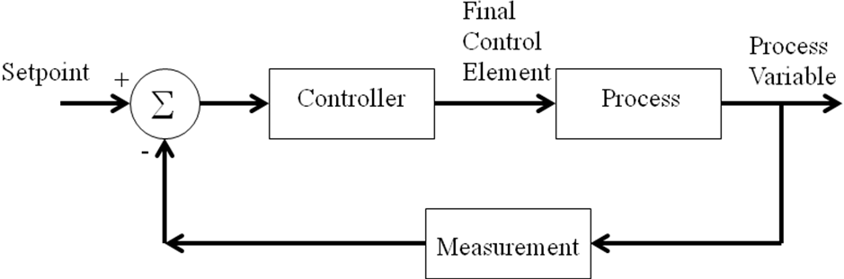

Figure #1 – Closed loop control system

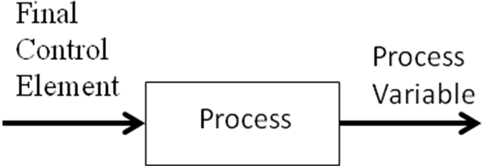

Figure #2 – Open Loop Control System

There are many different options in industry for control devices that implement open loop and closed loop control. Three of these control devices are listed below:

- Programmable Logic Controller (PLC);
- Distributed Control System (DCS);
- Data Acquisition System (typically PC based).

In this course, we will use the Data Acquisition System with LabVIEW as an interface platform for the measurements performed in lab.

LabVIEW is a PC based data acquisition software package that is used to provide control or displaying options for the measurement signal. A data acquisition card is interfaced to the computer through the PCI slots or via the USB port. The data acquisition card provides an interface point for the field measurement. The card will condition the signal to be read by the PC through the application software. The user can program LabVIEW to display, trend, or control the measured value. In order to make full use of the LabVIEW software, the hardware must be properly configured to read Analog &/or Digital Inputs and write Analog &/or Digital outputs. A device for reading transmitter signals and writing to output transducers are essential to the operation of a Data Acquisition and Control System.

This lab provides a very basic introduction to the LabVIEW software and demonstrates to the student how to configure the I/O using the Measurement and Automation Explorer (NI MAX) as well as how to configure the LabVIEW software to read inputs and write outputs.

Procedure:

- Start LabVIEW and run the program called temperature systems demo. This demo illustrates some of the features of LabVIEW. Under the Windows menu, choose “Show Block Diagram.” The diagram is the program developed in the “G” Programming language. The Front Panel that is in view is the operator interface.

- Build a VI with three Numeric Controls and one Numeric Indicator. The indicator should display the sum of the three control inputs. Save the VI.

- Build a VI with two Boolean Switches and two Boolean LED Indicators. LED indicator #1 should be on if either switch is ON. LED indicator #2 should be on if both switches are ON. Save the VI.

Configuring Inputs and Outputs

- Start Measurement and Automation Explorer (NI MAX) software.
- Connect the NI-ELVIS System to the computer and turn the ELVIS system on.
- From the MAX project tree on the left of the screen click on Devices and Interface.
- The system should automatically identify the NI-ELVIS system. Verify this to be correct. If not, then ask the instructor for assistance.
- Open LabVIEW and create a NEW VI.

Digital Input
- From the Front Panel, right click to access the Controls Palette. Select the Modern option. Create one Boolean Indicator (LED) and place it on the Front Panel.
- From the Block Diagram right click to access the Functions Palette. Select the Measurement I/O option. Locate the DAQ Assistant function block and place it on the Block Diagram.
- Placing the DAQ Assistant on the Block Diagram should automatically bring up the settings, select Acquire Signal and Digital Input. Choose DIO0 and configure for 1 Sample on Demand. To return to the settings if closed, Double Click on the DAQ Assistant block.
- Connect the DAQ Assistant to an ARRAY TO CLUSTER instruction & Unbundle instruction. Then connect to the Boolean Indicator. Include everything in a WHILE Loop.

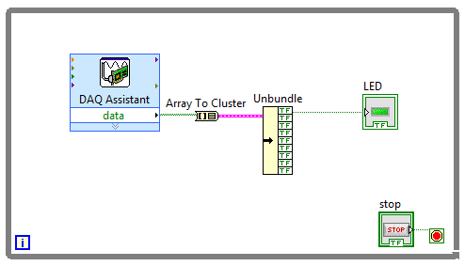
Digital Output

- From the Front Panel, right click to access the Controls Palette. Select the Modern option. Create one Boolean Control and place it on the Front Panel.
- From the Block Diagram right click to access the Functions Palette. Select Measurement I/O and locate the DAQ Assistant function block and place it on the Block Diagram.
- Placing the DAQ Assistant on the Block Diagram should automatically bring up the settings, select Generate Signal and Digital Output. Choose DIO1 and configure for 1 Sample on Demand. To return to the settings if closed, Double Click on the DAQ Assistant block.
- Connect the Boolean Control to a Bundle instruction & CLUSTER TO ARRAY instruction then to the DAQ Assist.

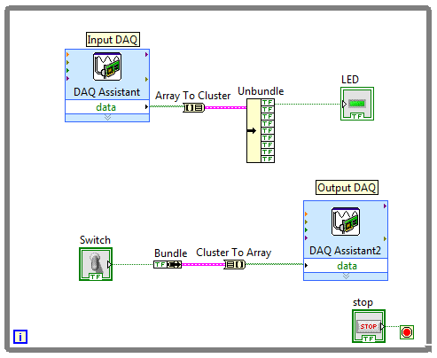
Field Verification

- Connect the Digital Output pin DIO1 to the Digital Input Pin DIO0. Also, connect the Digital Output to LED0 on the NI-ELVIS board to provide a low impedance load.
- When the Boolean Control of the Digital Output changes states from the Front Panel, the Boolean Indicator on the Front Panel should indicate the change in state. The LED on the NI-ELVIS should also illuminate.

Analog Input

- From the Front Panel, right click to access the Controls Palette. Select the Modern option. Create one Numeric Indicator on the Front Panel.
- From the Block Diagram right click to access the Functions Palette. Select Measurement I/O and locate the DAQ Assistant function block and place it on the Block Diagram.
- Placing the DAQ Assistant on the Block Diagram should automatically bring up the settings, select Acquire Signal and Voltage. Choose AI0 and configure for N Samples, a 0-10V range, and RSE for Terminal Configuration. To return to the settings if closed, Double Click on the DAQ Assistant block.
- From the Block Diagram/Functions Palette, place a from DDT (DDT-Numeric) function block found under Express/Signal Manipulation. Configuration settings should automatically open, select Single scalar under Conversion for Resulting data type. Connect the DAQ Assistant to the from DDT as the interface to the Numeric Indicator.

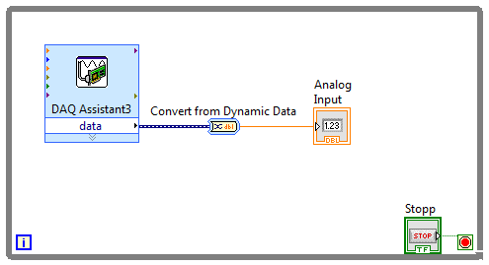
Analog Output

- From the Front Panel, right click to access the Controls Palette. Select the Modern option. Create one Numeric Control on the Front Panel.
- From the Block Diagram right click to access the Functions Palette. Select Measurement I/O and locate the DAQ Assistant function block and place it on the Block Diagram.
- Placing the DAQ Assistant on the Block Diagram should automatically bring up the settings, select Generate Signal and Voltage. Choose AO0 and configure for 1 Sample on Demand and a 0-10V range. To return to the settings if closed, Double Click on the DAQ Assistant block.
- From the Block Diagram/Functions Palette, place a to DDT (Numeric-DDT) function block found under Express/Signal Manipulation. Configuration settings should automatically open, select Single scalar under Conversion for Input data type. Connect the Numeric Control to the to DDT as the interface to the DAQ Assistant.

Field Verification

- Connect the Analog Output pin AO0 to the Analog Input Pin AI0. When the Numeric Control of the Analog Output is varied from the Front Panel, the Numeric Indicator on the Front Panel should indicate the voltage measurement over a range of 0-10VDC.

Lab Report

- Place all VIs for the above exercises in D2L Assignments/Dropbox Lab #1.

